December monthly report
Project Title:
Conversion of post-combustion gas from cement manufacturing to syngas by electrochemical CO₂ capture and reduction
……..........................................................
Dr. Pongkarn Chakthranont
Sothearoth Heng
NCR ID: 803198
Under the supervision of
Dr. Pongkarn Chakthranont
Contract Number: NCR-NN-2024-22237-EN
December 2024

- Tasks list for November
- Long-term stability under a pure 10ml/min CO₂ with 0.5M KOH electrolyte at a current density range of 100-200mA/cm²
- Revisiting the acid-treated NiSAC catalyst performance under a diluted 15%CO₂ at 200mA/cm²
- Experimental Procedure
Preparation of acid-treated Ni-SAC catalyst
200mg of Ni-SAC was added into a 50ml of 1M H₂SO₄ solution, followed by overnight stirring to leach out of the excess Ni metal. The acid-treated Ni-SAC was then filtered out and neutralized with DI water for several times. Afterwards, the acid-treated Ni-SAC was dried in an oven at 80°C for 6h.

Long-term stability of CO₂ electrolysis
A 5 cm² MEA electrolyzer was used to evaluate the CO2RR performance under modulated operating conditions. The Ni foam, bipolar membrane (BPM), and different cathode catalysts were employed as the anode, membrane, and cathode electrode, respectively. 500 ml of 0.5 KOH was recirculated and used throughout the experiment as the anolyte at 8 ml/min. The KOH electrolyte was refreshed every 24h, while the NiSAC cathode was also flushed with 10ml of DI water. The humidified CO₂ gas stream was introduced into the cathodic inlet under total flow rates of 10 ml/min. Meanwhile, the cathodic outlet was directly injected into an online gas-chromatography for gas products analysis.

- Results

Long-term CO₂ electrolysis of Ni-SAC under a pure 10ml/min CO₂ with Ni foam and 0.5M KOH anolyte at 100-200mA/cm²
In order to maximize the single-pass CO₂ utilization (SPU) while maintaining the durability of the overall system, the long-term performance of NiSAC under a lower CO₂ gas stream of 10 mL/min was evaluated at 100 and 200 mA/cm². At 100 mA/cm², the overall system demonstrated high stability with an FE(CO) of 93% and an SPU of 32% for an operational duration of 40 hours. Meanwhile, the system operated at 200 mA/cm² achieved the highest SPU of 64% with an FE(CO) of approximately 88% for an operational duration of 10 hours. These results, therefore, demonstrate the trade-off between the longevity and SPU of the overall system, which must be taken into account.
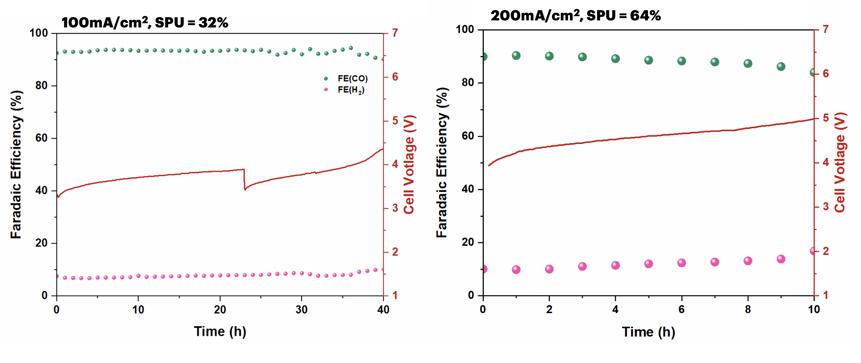
Figure 1. Long-term stability of NiSAC under 10ml/min CO₂ at 100-200mA/cm²

CO2RR performance of NiSAC and acid-treated NiSAC catalysts under a diluted 15%CO₂ condition
To further investigate the influence of excess Ni metal content and the hydrophobicity of the catalyst, the CO₂RR performance of both bare NiSAC and acid-treated NiSAC with different NiPc precursor loadings (0.5, 1, and 2 g) was experimentally evaluated. As shown in Fig. 2, the bare and acid-treated NiSAC exhibited similar results, except for the acid-treated Ni0.5SAC, which showed a significant decrease in FE(CO) compared to bare NiSAC. These results highlight the importance of the NiPc precursor ratio during the synthesis process for catalyst performance, particularly when acid pre-treatment of the NiSAC is required. Interestingly, the bare NiSAC catalyst (with 1 and 2 g of NiPc) demonstrated comparable CO selectivity to the acid-treated NiSAC while maintaining higher hydrophobicity. The long-term stability of both bare and acid-treated Ni1SAC shown in Fig.3 is further confirmed the loss of hydrophobicity and the surface change of the catalyst after undergoing the acid pre-treatment, even though a higher FE(CO) of 87% was achieved with the acid-treated Ni1SAC. Therefore, the removal of excess Ni metal appears to be an unnecessary procedure.
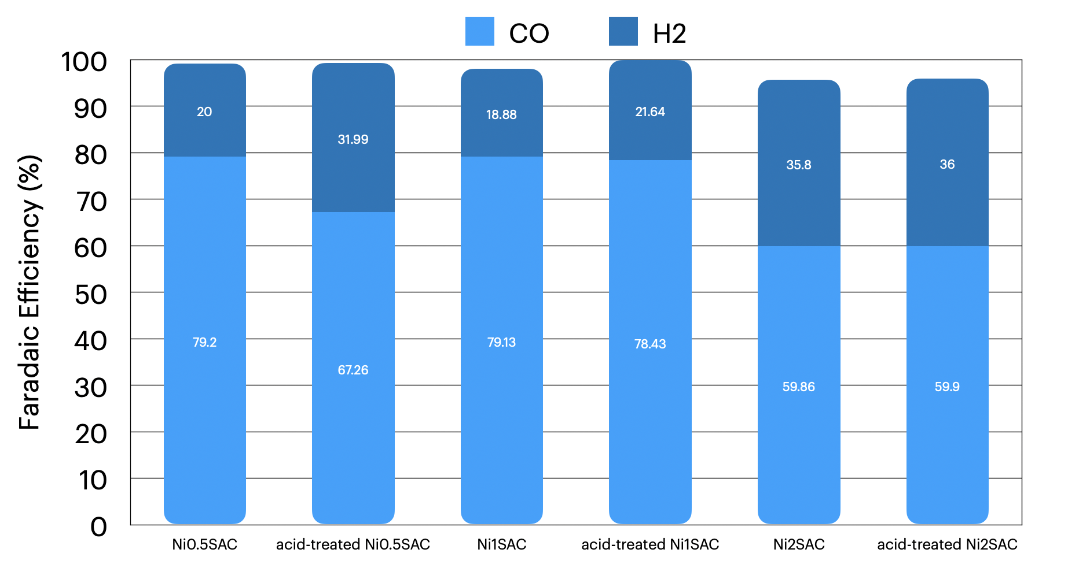
Figure 2. Faradaic efficiency of bare-NiSAC and acid-treated NiSAC under 15%CO₂ gas
stream and 200mA/cm²

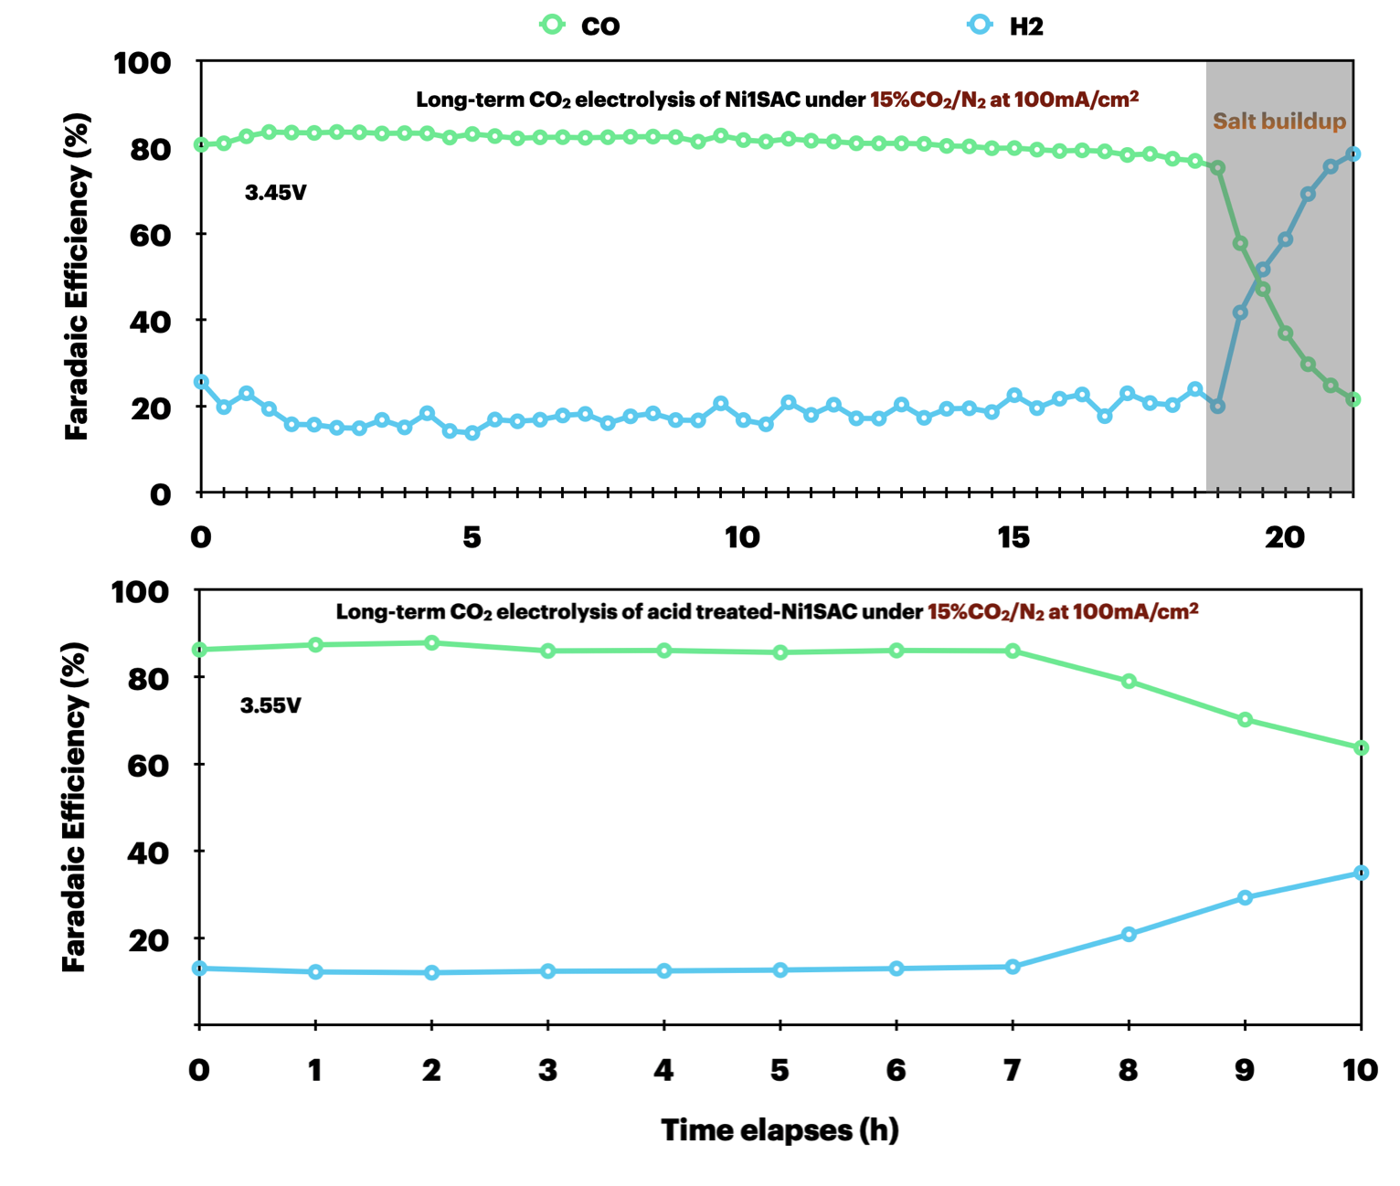
Figure 3. Long-term CO₂ electrolysis of bare and acid-treated Ni1SAC under a diluted 15%CO₂ with 0.5M KOH at 100mA/cm²

- Upcoming tasks
- Synthesis of NiSAC (0.25, 0.5, 1.0, and 2.0) for further characterization
- Long-term stability under a pure CO₂ with diluted KOH electrolyte at 200mA/cm²
- Long-term stability under flue gas conditions

